FAKE OR REAL JOB POSTING PREDICTION

BY

RAMANI REDDY

AVINASH YAVVARI

UNDER PROFESSOR

DUODUO LIAO

AIT 590 : INTRODUCTION TO NATURAL LANGUAGE PROCESSING



GEORGE MASON UNIVERSITY

05/16/2019

**TITLE:** FAKE OR REAL JOB POSTING PREDICTION

**ABSTRACT:**

Fake job postings have deceived a number of jobseekers by wasting their time and effort in filling out the applications and waiting for response. Jobseekers have also had financial consequences due to these fake job postings as they ask you to travel considerable distances to interview for fake roles. It takes a lot of time for these job postings to be detected and removed from the websites. In order to detect these job postings, many people have worked on the employment scam dataset that has been published by The University of Aegean. In previous works, we notice that TF-IDF or Count vectorizer is used to convert the text data to word count vectors or word frequency vectors. Later, models like Logistic Regression, Naïve Bayes and some other classification algorithms were used to classify the data into fraudulent or non-fraudulent job posting. Recently, some people have also used regular artificial neural networks and LSTM along with Bert or 200 dimension Glove for word embedding. All these models have achieved very good accuracies.

We have implemented Logistic regression and Naïve Bayes as our baseline models to see how they perform on our unbalanced data. To balance the data we have Oversampled the data and implemented our baseline models on this data. We noticed that the model had started performing better. To improve the accuracy we have chosen to work with CNN models on our oversampled data and used Google’s pre-trained model Glove 300d to perform word embedding. We have evaluated all our models and found out that CNN model works the best by achieving the highest accuracy.

(Dorion, n.d.)

**INTRODUCTION:**

It is important to know if one is applying for a genuine job posting or a fake job posting as he can apply for hundreds of companies mentioned in the job boards and hardly receive any interview calls. It not only wastes his time but also his energy and hope of getting a job. Companies often fake hiring ads in order to get market intel or use their job posting credits. It is necessary for us to know which companies are fake and genuine so that the genuine job posting companies don’t waste their time and resources and the ones seeking a job can achieve more by matching better.

In this project, we aim to classify a job posting as a fake or real one by taking the job posting’s title, profile of the company and other significant texts such as job description, requirements, benefits and many more. We chose Logistic Regression and Naïve Bayes as our baseline model. As our hypothesis is that only job description and requirements are the significant features for predicting fraudulent or non-fraudulent job postings, we implemented our models by considering only some features of the dataset as we wanted to check if our hypothesis was true. We realized that these features are not sufficient and decided to use the remaining features. Though we used all the features the model did not perform well. To address this issue we did analysis on weights and decided to oversample the data and implement the baseline models on the oversampled data. The model performance had shown great improvement. We moved on to implement the CNN model and chose the Glove 300 for word embedding. We will see how we chose a series of hyper tuning parameters and tested it to select the best parameters that helped us achieve 97% accuracy. We will also explain the experiment results of each model and also evaluate the model results.

(Albert, n.d.)

**RELATED WORK:**

Previously, some coders on Kaggle have done data preprocessing and text processing to remove stop words, special characters and stemming was done to reduce words to their affixes or suffixes. Later, TF-IDF or Count vectorizer was used to convert the text data to word count vectors or word frequency vectors. This was done as the Machine Learning algorithms cannot understand text data but only understand numeric data. Models like Logistic Regression, Naïve Bayes and some other classification algorithms were used to classify the data into fraudulent or non-fraudulent job posting. Others have come up with artificial neural networks and LSTM for predicting the classes of the target variable. Pre-trained models like Bert or 200d Glove were used for word embedding.

We have also come across some works that used Keras framework. Some works also include CNN models. We have used TF-IDF vectorizer on oversampled data and implemented Baseline models on this oversampled data which was not done previously. We also used Glove 300d instead of Glove 200d ,100d or Bert for word embedding and also included embedding layer with convolutional one dimensional layers in our CNN models as this was not done earlier. Our main work that distinguishes our work from others is implementing CNN model on oversampled data. We will see how this was done and what results we got in the upcoming sections.

(Madz, 2020)

(Singh, n.d.)

**OBJECTIVES:**

The main objectives of doing this project are:

* To predict if a job posting is a fraudulent posting or a genuine posting using our baseline models and score the models.
* To preprocess the data by cleaning it and then converting the text data into word frequency vector by using TFIDF.
* To see if job description and job requirements are the only significant features or the other features are also important.
* Do analysis of weights to know if oversampling can increase the model performance or not.
* Do oversampling and then split the data into train and test data.
* Choosing the right hyper tuning parameters for our CNN model.
* To implement our baseline models and CNN model on this oversampled data and score the models.
* Evaluate the models to see which model works the best for our dataset.

**THE DATASET:**

**SELECTION:**

This dataset was selected as it is about employment scam and as we know during this pandemic, many people have lost their jobs and the number of jobseekers is increasing every day. This is the time scammers try to deceive the genuine jobseekers and make money out of fake advertisements or even do trafficking by sending them to another place. This can be stopped if we can utilize the text data of the dataset to classify the job posting as fake or real.

(EMSCAD logoEmployment Scam Aegean Dataset, 2014)

**DESCRIPTION:**

The dataset was provided by the University of the Aegean, Laboratory of Information & Communication system security. The data set consists of 18k job descriptions out of which 800 are fake. This data set has 18 columns which consists of some significant variables with textual data. These jobs have been publishes between 2012 and 2014. The email ids, phone numbers and other contact information had been masked in this dataset.

Description of the data set :

|  |  |  |
| --- | --- | --- |
| **Column Name** | **Object** | **Description** |
| Job_id | id | Unique job id |
| title | String | The title of the job ad entry. |
| location | Address | Geographical location of the job ad. |
| Department | String | Corporate department (e.g. sales). |
| Salary_range | String | Indicative salary range (e.g. $50,000-$60,000) |
| Company_profile | String | A brief company description. |
| description | String | The details description of the job ad. |
| requirements | String | Enlisted requirements for the job opening. |
| benefits | String | Enlisted offered benefits by the employer. |
| telecommuting | Integer | True for telecommuting positions. |
| Has_company_logo | integer | True if company logo is present. |
| Has_questions | integer | True if screening questions are present. |
| Employement_type | String | Full-type, Part-time, Contract, etc. |
| Required_experience | String | Executive, Entry level, Intern, etc. |
| Required_education | String | Doctorate, Master’s Degree, Bachelor, etc. |
| industry | String | Automotive, IT, Health care, Real estate, etc. |
| function | String | Consulting, Engineering, Research, Sales etc. |
| fraudulent | integer | Classification attribute. |

**DATA PREPROCESSING:**

The first step of data preprocessing is to clean our data that is a little messy. We decided to drop the columns Department, salary range, required experience and required education as more than 80% of the data was missing in these columns. The next step was to drop columns that would cause word ambiguity. For instance, in the column location we had country names as US for The United States or NZ for New Zealand. There is a chance that our model is most likely to consider the word US to be a pronoun “us” than a country called United States. This will result in word ambiguity which we would like to avoid. Hence, we dropped the column Location. We also dropped the column named Industry as it was similar to the column Function. The Industry column had the industry name and Function column had the different job roles of that particular Industry. Due to this, we will have similar words in both the columns with the same meaning. For example, the Industry column can have Production and Function can have Production Management. This will cause an imbalance in the TF-IDF matrix as both the columns have null values. To avoid this we drop the Industry column. There was one missing value for description column so we decided to drop it as well.

For the next step, we have replaced the Null values of columns containing text data with the word “Noinformation”. These columns include requirements, benefits and company profile. The function column had around 37 unique values as well as some missing data. We categorized these 37 unique values into five different categories depending on the type of industry. The values replaced are :

* Marketing, Finance, Advertising ,Accounting/Auditing, Writing/Editing and Legal were replaced with “Marketing and Finance”.
* Customer Service, Consulting, Health Care provider, Art/Creative, Science, Training, Education, Research were replaced with “Other”.
* Production, Supply chain, Design, Manufacturing, Quality Assurance, Distribution, Purchasing were replaced with “Sales”.
* Administrative, Business Development, Project Management, Human Resources, Public Relations, Strategy/Planning, General Business, Product management were replaced with “Management”.
* Information Technology, Engineering, Data Analyst, Business Analyst, Financial Analyst were replaced “Information Technology”.

The null values of Function and employment type have been replaced using the mode of these two columns. We performed one hot encoding on these two columns as we had different categories in them. The columns with text data were joined with a space in between them and the output was stored in another variable. This variable was named job data and it was now joined to a new data frame. The one hot encoded columns as well as fraudulent column were also added to this new data frame excluding the columns used to create the job data column.

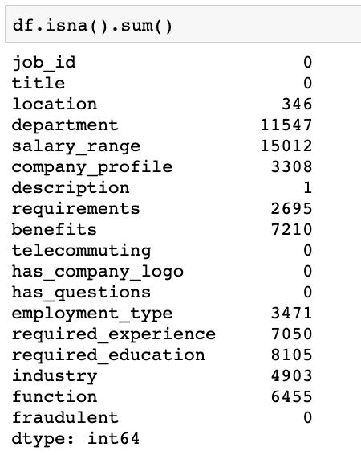 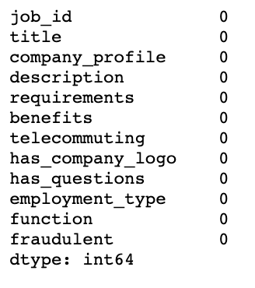

**Fig 1: Before data Preprocessing Fig 2: After Data Preprocessing**

**TEXT PREPROCESSING:**

In text preprocessing, we will clean the text data by removing any emojis, special characters excluding exclamation mark, symbols and change all the sentences into lower case. We will then perform stemming using PorterStemmer().

(Monsters, 2018)

**EXPLORATORY ANALYSIS:**

In the first plot, we notice that the count of non-fraudulent data is very high in the comparison to that of fraudulent data. This actually shows us that there is a lot of bias in the data even before using machine learning models to make predictions. But in order to see how the predictions are made with this bias in the data we have implemented the baseline models.

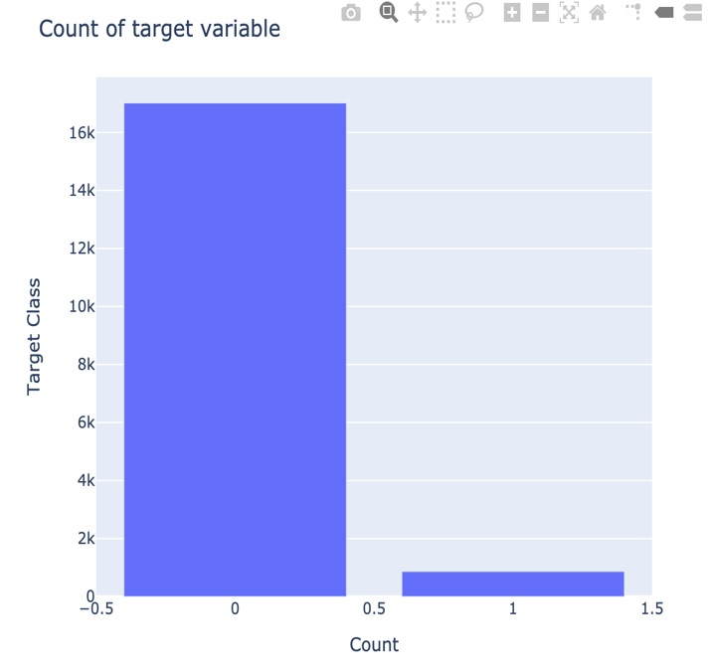

**Fig 3: Comparison of non-fraudulent and fraudulent values in the dataset**

In the next plot, we see that the most fraudulent jobs belong to the Information technology category. This could be due to the increasing number of software engineers and information technology graduates every year.

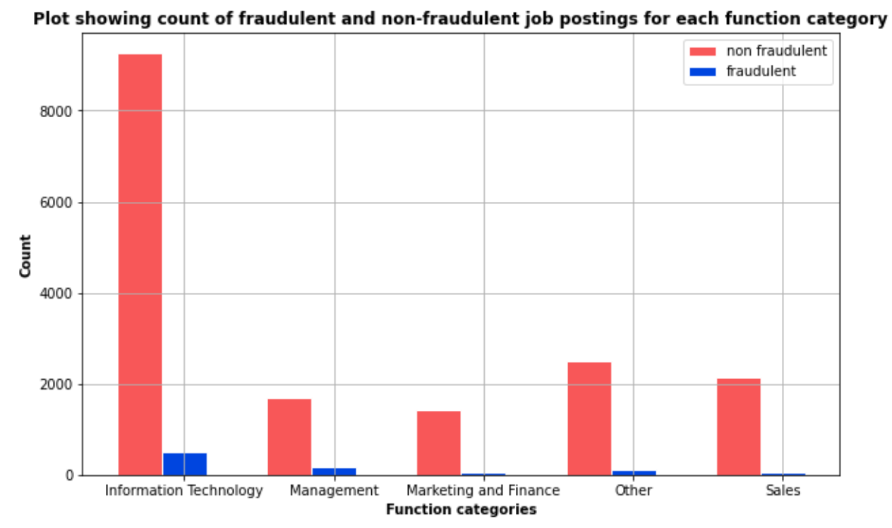

**Fig 4: Count of Fraudulent and Non-fraudulent job postings in different industries**

In the next plot , we see that most fraudulent jobs post for full-time job seekers and part-time job seekers. They are hardly an fake job postings for Temporary jobs. This could be because most jobseekers do not look for temporary jobs.

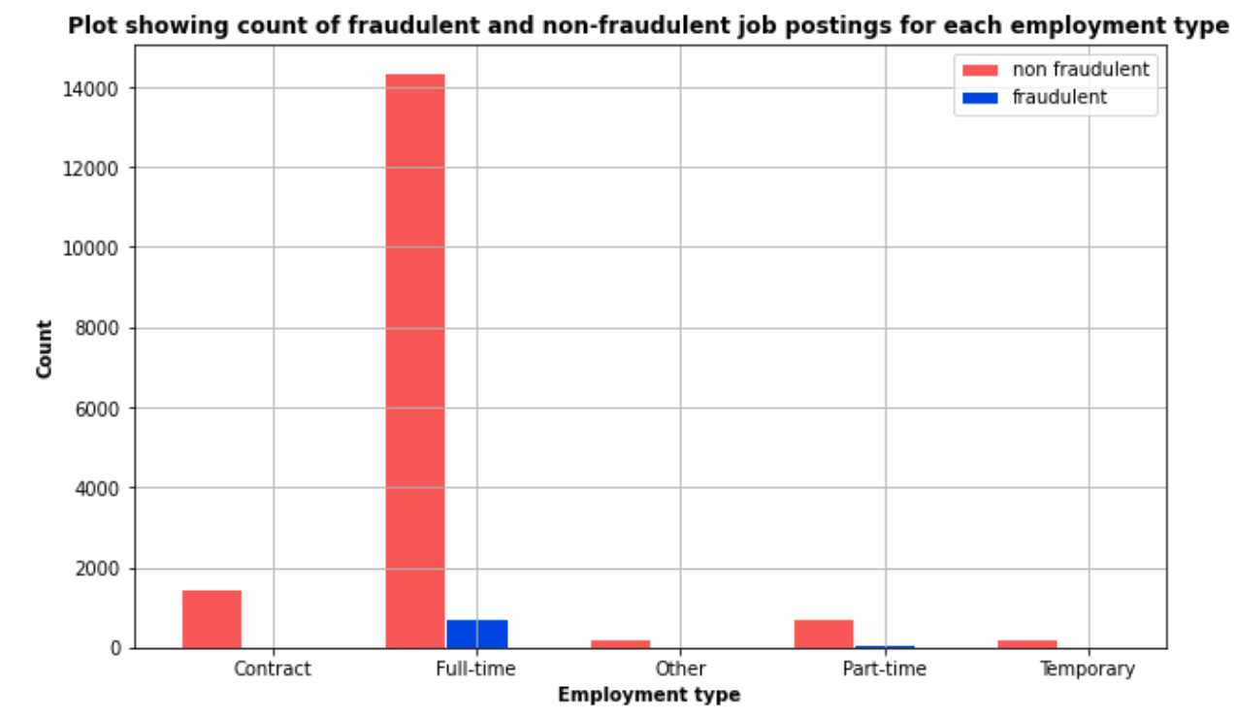

**Fig 5: Count of Fraudulent and Non-fraudulent job postings for different employment type**

(Gaudard, n.d.)

**THE SYSTEM:**

**ARCHITECTURE OVERWIEW:**

* The first step is to process the text data and numeric data.
* The next step is to generate a TF-IDF matrix for only job description and requirements features and run our baseline models on it to analyze the results.
* For the next step, we will repeat the second step but instead of considering only two features we generate a TF-IDF matrix for all the text data columns. We will horizontally stack the one hot encoded features with the TF-IDF matrix.
* Now we implement our models on this new all features table and analyze the results.
* The next step is to do n-gram analysis and find a solution to get more accuracy. We will use oversampling to achieve more accuracy in this case.
* We implement our baseline models on this oversampled data and analyze the results.
* If we get optimal solution we move on to implement the CNN model and start this by doing word embedding.
* We will attach word embedding to our CNN layers and hyper tune the parameters. After running the models, we will analyze its results and then evaluate all our models.

**ARCHITECTURE:**

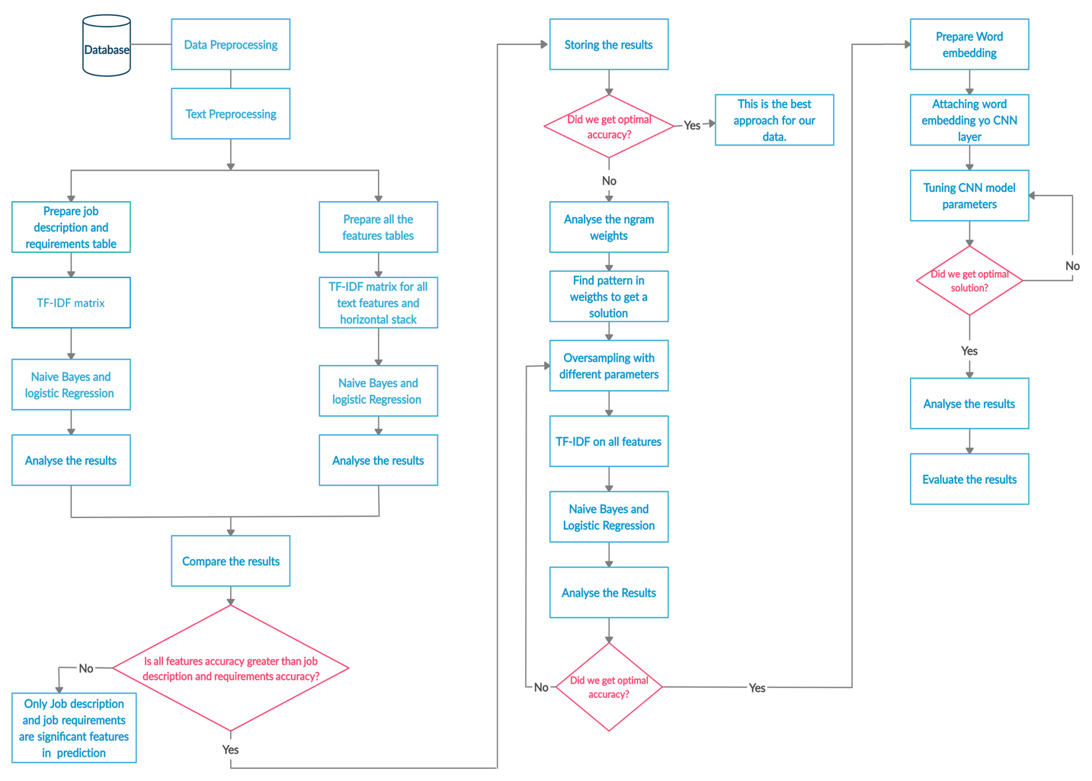

**FIG 6: Conceptual Diagram**

**NATURAL LANGUAGE PROCESSING AND DATA ANALYTICS APPROACHES:**

**Implementing Baseline models to formulate solutions from the results.**

**Implementing Baseline models by considering only job Description and job requirements features:**

For the first part, we wanted to check if job description and job requirements alone are sufficient to predict fraudulent and non-fraudulent job postings or not. To do so, we have only taken job description and job requirements columns and combined these two columns into one column named job_text.

**TF-IDF ( Term Frequency – Inverse Document Frequency):**

TF-IDF is statistical measure to evaluate the relevance of a term is in a given document. The main idea of this concept is to check the frequency of a word in a document and tell if it is a relevant word. We focus on relevant words as they are the ones which give more meaning to the document rather than just occurring multiple times in different documents. For example, stop words like a, an or the can occur multiple times but do not have any meaning so they cannot be called relevant words. TF-IDF works by increasing the proportionally to the number of times a word appears in the document, but is offset by the number of documents that contain the word. We calculate TF-IDF using two metrics. One is term frequency and the other is inverse document frequency.

**Term Frequency**- Counting the number of times a word occurs in a document.

**Inverse Document Frequency**- The frequency of a word in all the documents. Closer the count is to 0, the more common the word is in all the documents.

**Term Frequency Formula - **

**Inverse Document Frequency Formula-** 

**TF-IDF score Formula-** 

(Stecanella, 2019)

**TF-IDF on job_text column:**

We transformed the combined text data, job_text, into a TF-IDF matrix. In this matrix, the term frequency of a record and the Inverse document frequency of the entire vocabulary is used to computed the TF-IDF score for all the n-grams of a document. These scores are stored in a matrix called the TF-IDF matrix. The transformation of data into TF-IDF matrix was done by taking n-grams range as (1,2), which means we have used unigrams and bigrams and removed the specified stop words such as “the”, ”a” and ”an”. We then performed K-Fold Cross Validation using k value as 5 folds.

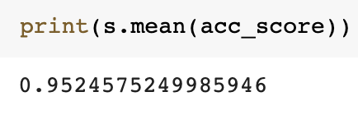

**Fig 7 : Cross validation score**

**Naïve Bayes model using only job description and requirements:**

After we transformed the text data into TF-IDF matrix, we implemented Naïve Bayes model on this matrix. In this model we used the smoothing factor so that the words not present in the vocabulary do not make the probability of the algorithm 0. To make sure this does not happen, we will add 1 to the fraudulent and non-fraudulent data in the probability formula. We do this by using the parameter called alpha. We take the value of alpha=1. We notice that fraudulent data is not being classified accurately.

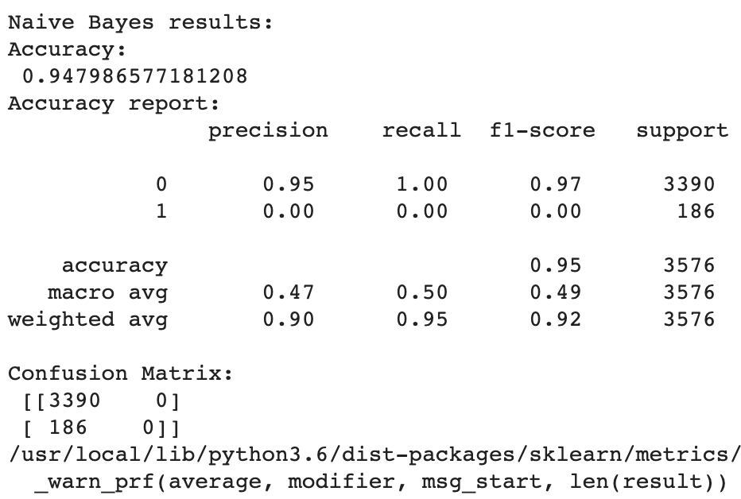

**Fig 8: Naïve Bayes result using job description and job requirements**

**Logistic regression model using only job description and requirements:**

In Logistic regression model, we will again use the TF-IDF matrix and used the default parameters to see how it works. We notice that only few fraudulent job postings are predicted correctly. Though the overall accuracy is high, the fraudulent class prediction has to be improved. Now we will consider all the other features and make predictions to see if there is any difference.

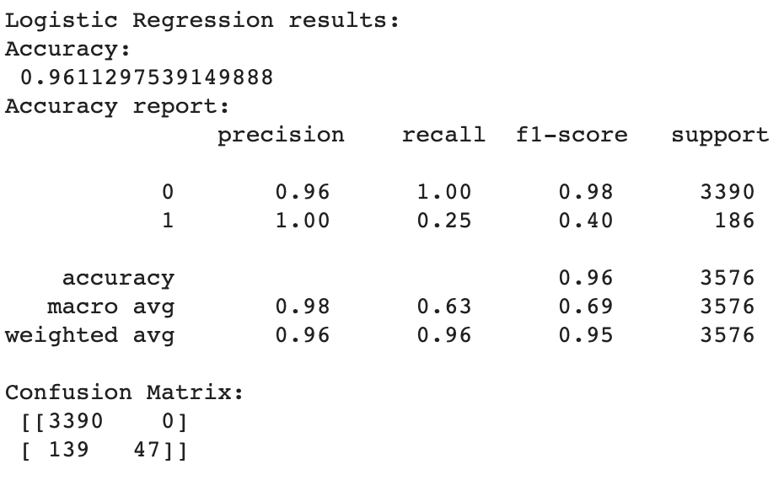

**Fig 9: Logistic Regression result using job description and job requirements**

**Implementing Baseline models by considering all features:**

**Naïve Bayes model using all the features:**

We use the same parameters used in the beginning. We have combined all the text features into one column called job_data and performed TF-IDF vectorization on it. Later, we horizontally stacked the other features to the TF-IDF matrix and performed Naïve Bayes on this data. We notice that the overall accuracy has increased but there is no difference in fraudulent data classification. So let us use Logistic Regression and see the results.

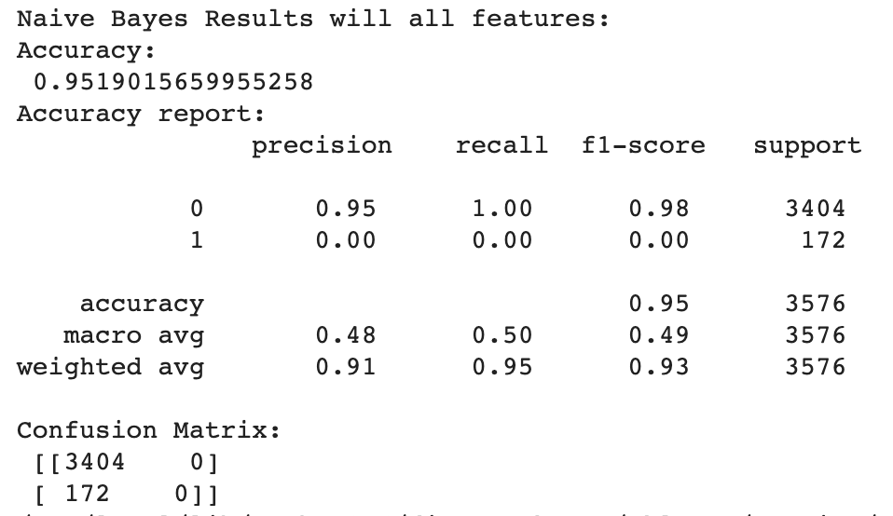

**Fig 10 : Naïve Bayes result using all features**

**Logistic regression model using all features:**

We use the same default parameters used in the beginning. We have combined all the text features into one column called job_data and performed TF-IDF vectorization on it. Later, we horizontally stacked the other features to the TF-IDF matrix and performed Logistic Regression on this data. We notice that the overall accuracy has increased but there is no difference in fraudulent data classification. So let us change the parameters and see the results.

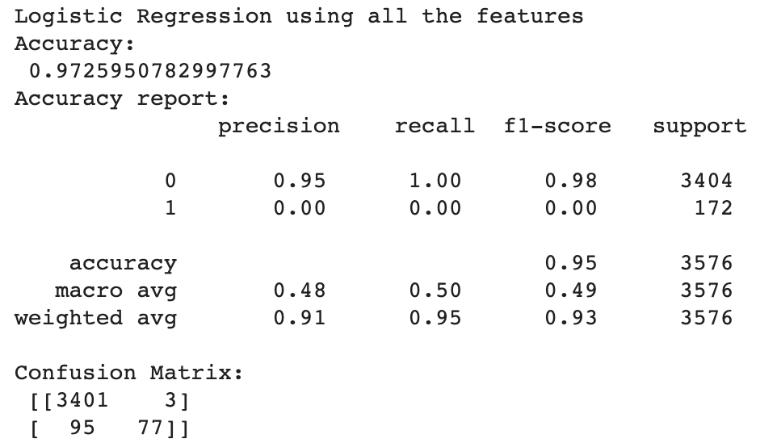

**Fig 11: Logistic Regression result using all features**

**Logistic regression model using all features and changing parameters:**

We changed the parameter penalty to l2 and solver parameter to ‘lbfgs’. As our problem is a classification problem, we will the set the multi_class parameter to ‘ovr’ and run the model on the matrix. We notice that the model does not perform well for the fraudulent data though the overall accuracy has increased. The reason could be due to the high bias in non-fraudulent data which we will discuss later in brief.

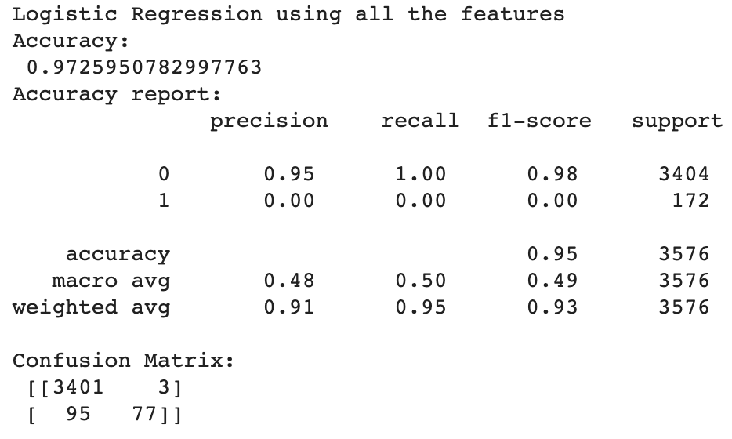

**Fig 12: Logistic Regression result using all features and changing parameters**

**Logistic regression model using all features and changing class_weight parameter:**

We assumed that the problem is due to high bias as all the models are not able to classify the fraudulent data only. To check if this assumption was true, we gave importance to the weights of low bias class which is fraudulent class. In this case, we will tell the model that low bias class weights (fraudulent) should be given more priority and less priority to high bias class weights (non-fraudulent). We do so by setting the parameter called class_weight to “balanced”. This will adjust the weights inversely proportional to the class frequencies in the input data. Due to the inverse proportionality, the weights of high bias class will turn into the weights of low bias class and vice versa. Formula for this inverse proportionality is:

**Number of samples/(Number of classes *np.bincount(y))**



**Fig 13: Logistic Regression result using all features and changing class_weight to balanced**

**Evaluation of all the Models Performance :**

By implementing Naïve Bayes and Logistic Regression models considering all features and some features, we arrived at a conclusion that job description and job requirements are not the only significant features. Even after changing the class_weight parameter as balanced for the Logistic Regression Model, we notice that fraudulent data is classified correctly but non fraudulent predictions are affected. We also do not notice any significant changes in all the five models performance implemented. This proves our assumption wrong that giving priority to low bias class weights and less priority to high bias class weights will improve the model performance.

**Formulating solutions to address the issues:**

To address this issue, we have come up with another assumption that increasing the low bias class weights while keeping the high bias class weights constant will improve the model performance. This can be done by increasing the frequency of features appearing in fraudulent records. We came up with this new assumption as the TF-IDF matrix depends on word frequency of documents as well as vocabulary. Based on this assumption, our hull hypothesis is that oversampling the data will allow us to classify the fraudulent data correctly. We will discuss this in the next section briefly.

**Oversampling the data and then implementing the Machine Learning Models**

**Oversampling the data:**

Oversampling is done to adjust the distribution of class in a dataset. In oversampling, the imbalance in the dataset caused by the minority class is removed. We will perform oversampling of our dataset by performing a series of experiments on the low bias class. The number of times the low bias data has to be duplicated will be decided after the average accuracy is determined by doing cross validation. We perform cross validation before doing oversampling to avoid overfitting of the data. After we completed the above steps, we concluded that at a point of 17 times the class with low bias, which is fraudulent, gets duplicated to achieve an optimal accuracy of 98%. We will then extract all the text data features and perform TF-IDF vectorization with the ngram range (1,2) which means that we specify it to take only unigrams and bigrams.

(Dataman, 2018)



**Fig 14: Oversampling of data after Cross Validation**

We will now fit the vectorizer on the train data and test data to transform the data into a TF-IDF sparse matrix. Now considering all the other features, we will horizontally stack the word frequency matrix to all the remaining features on both the train and test data. We now perform the Cross validation on the inside with respect to the indexes so that we do not have any leakage of data inside the cross validation. As mentioned earlier, we took 5 folds as our dataset as it has less number of records. We will now use Naïve Bayes and Logistic Regression and use oversampled data to train the model. We will discuss the results of each model in the coming sections.

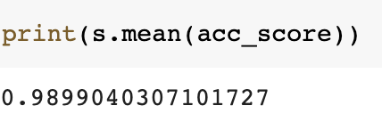

**Fig 15: Cross validation score**

**Logistic Regression on Oversampled data:**

We have used the same default parameters. Now we implement this model on oversampled data. Once our assumption is proved to be true, we will perform Naïve Bayes model as well. We then analyzed the results and saw that even low bias data is now being predicted pretty well. The precision of fraudulent data was 0.0 but now it has become 0.67 which tells us that fraudulent data is getting classified better than before. We got an accuracy of 97%.

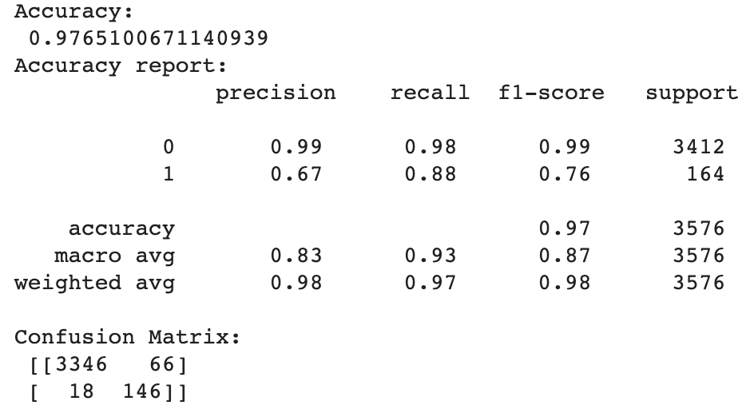

**Fig 16: Logistic Regression on Oversampled data**

**Naïve Bayes on Oversampled data:**

We take the value of alpha=1. After implementing the model on oversampled data, we noticed that even Naïve Bayes performed well by predicting the fraudulent data with optimal accuracy. It performed equally well to logistic regression and the precision of fraudulent data is also 0.67 now which is better than what we got earlier without oversampling.

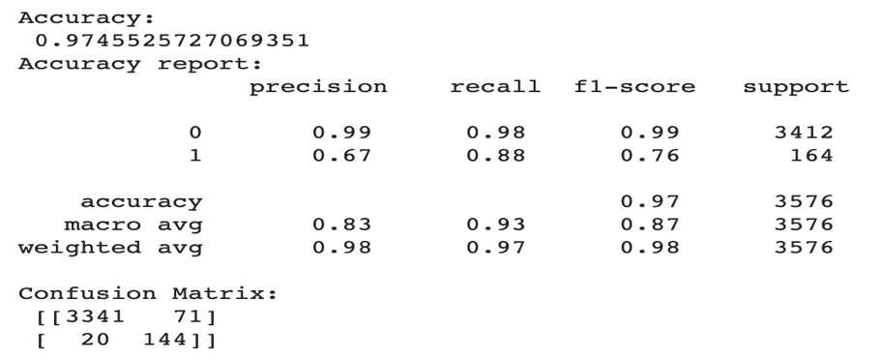

**Fig 17: Naïve Bayes on Oversampled data**

**Results of analysis:**

Results show that we have achieved 97% accuracy for both the models. This means that oversampling has now made the low bias class to be classified accurately. From this analysis our null hypothesis that oversampling will allow us to classify fraudulent data accurately has been accepted.

**Next analysis:**

So we can conclude that, performing Neural Networks model on oversampled data may give better results.

**Implementing Convolutional Neural Network model on Oversampled data**

The last part of our project is to implement CNN models on oversampled data and see how well the model performs than the other two classification algorithms we have used. We will also do word embedding instead of working with word frequency matrix.

**Word embedding:**

Word embedding is a popular way of representing the vocabulary of a document. It has the capability to understand in which context a word is used, similarity between words and the relationship between the words. We will do word embedding using Glove 300d.

(Brownlee, 2017)

**Glove 300d :**

Global vector is an unsupervised learning algorithm that is used to obtain the vector that has different word representations. It is pre-trained model developed by Google and it is made available to all under the Public Domain Dedication and License. They are different models in Glove but we will be using the 300d text file. Using this we will do word embedding and convert our text data words into unique numbers based on the values assigned to these words in the corpus. (Stanford University, n.d.)

**Convolutional Neural Network model on oversampled data:**

We have considered CNN model after doing some research as it works best for text data. We first use tokenize encoder to transform the tokens to unique numbers which glove will detect and transform to a 300 dimension vector. The first layer is the embedding layer where each job_data is converted to a 200 dimension vector list. We are taking a 1 dimensional convolution because our text represents a one dimensional vector. After a series of hyper tuning experiments were conducted, we concluded that taking neuron as 100 and kernel size as 2 will give us most accuracy. Kernel size 2 represents that network is taking 2 words at a time. The maximum pooling 1 dimension tells us that for every two cells we will take one cell which is significant. The spatial dropout is used to avoid overfitting. Then we flatten the 80% of the data again to form a 1 dimension vector and then use dense layer. The loss is binary cross entropy and activation is sigmoid because our problem is classification problem is binary and the sigmoid classifies values from 0 to 0.5 as 0 and 0.5 to 1 as 1. Then the optimizer is set to ’**adam**’ as optimizer convergence level is very high and fast in large datasets.

After a few experiments were conducted, we decided to use two layer because when we used 3 or 4 layers they were many fluctuations in the accuracy scores and this made it clear that using more than two layer would cause overfitting. We then performed hyper tuning by taking the epochs as 30 but after the 4th and 5th epochs we found that an optimal accuracy was reached so we took the final epochs size as 3 and batch size as 64. We got a validation accuracy of 99.75% on the train set for the 3rd epochs. When the model was used to predict the test data we got an accuracy of 97.9%.

(Peixeiro, 2019)

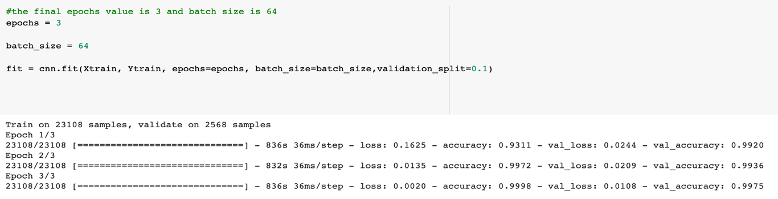

**Fig 18: Epochs as 3, the validation accuracy for each epochs is shown**

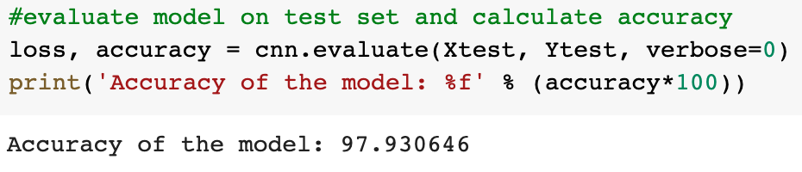

**Fig 19: Evaluate the model using the test data.**

The summary of the model shows us the parameters used and what is the shape of these parameters.

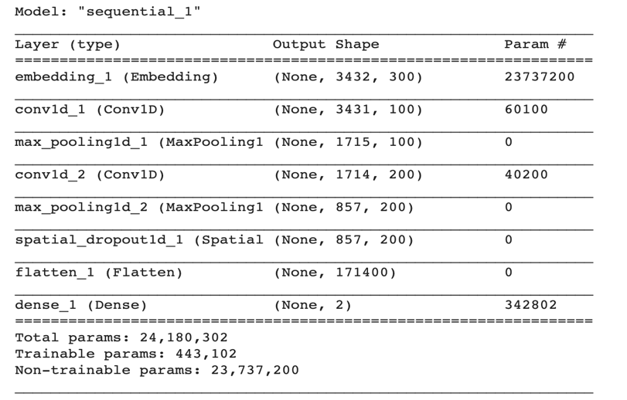

**Fig 20: Summary of the model**

**Analysis of results:**

The CNN model only showed little improvement than the previous models implemented. Changing the parameters by doing hyper tuning them could be done but due to hardware constraints we could only tune certain parameters. But the model reached optimal accuracy which is the reason we say that CNN model works the best for our data.

**SOFTWARE AND HARDWARE DEVELOPMENT PALTFORMS:**

**SOFTWARE PLATFORM-** Jupyter notebook, Jupyter Lab, Machine learning packages, Google collab

**HARDWARE PLATFORM-**

As we are doing oversampling, we will have to change our system architecture. We have used Google Cloud to run our code for CNN model. We created an instance in the Google cloud. Instance specifications are CPU 16 core 60 GB RAM, GPU Nvidia Tesla V100.

**EXPERIMENT RESULTS AND ANALYSIS:**

**Experiment Results:**

|  |  |  |
| --- | --- | --- |
| **Models** | **Cross Validation Score** | **Accuracy** |
| Naïve Bayes on job_text | 0.9542 | 0. 9479 |
| Logistic Regression on job_text | 0.9542 | 0.9611 |
| Naïve Bayes on all features | 0.9515 | 0.9519 |
| Logistic Regression on all features | 0.9515 | 0.9725 |
| Logistic Regression on all features by changing parameters | 0.9515 | 0.9725 |
| Logistic Regression on all features by changing class weight to balanced | 0.9515 | 0.9611 |
| Naïve Bayes on Oversampled data | 0.9899 | 0.9745 |
| Logistic Regression model on oversampled data | 0.9899 | 0.9765 |
| CNN model | - | 0.9793 |

**Note*- Due to hardware constraints we did not perform Cross validation for CNN model.**

**EVALUATION OF MODELS:**

**Evaluation of baseline models on job description and job requirements:**

As we discussed in the earlier section, the cross validation score for this model was 0.95. Naïve Bayes gets an accuracy of 94% and Logistic Regression got an accuracy of 96%. Form this, we understood that Logistic Regression worked better for just job description and job requirements features. Though both the models performed well, we notice that the low bias class which is fraudulent data is not classified accurately. To solve this issue we consider all the other features and implement the baseline models as well.



**Fig 21: Logistic Regression gave better results for this data**

**Evaluation of baseline models on all features:**

We implemented cross validation on the all features and text data called job_data, by combining text features with other features using horizontal stack. We notice that cross validation score for this data was 0.95 as well. Naïve Bayes gets an accuracy of 95% and Logistic Regression got an accuracy of 97%. Form this, we understood that Logistic Regression worked better for all features. Though both the models performed well, we again notice that the low bias class is not classified accurately. To solve this issue, we changed the parameters of Logistic Regression from default to penalty as l2 and solver as ‘lbgfs’ along with multi_class as ‘ovr’. This didn’t have much difference as the accuracy was still 97% and low bias data still didn’t have improvement in being classified with optimal accuracy. To solve this issue a new parameter called class_weights was set to balanced to increase weights of low bias data. This parameter helped in predicting fraudulent data with optimal accuracy but the overall accuracy of the model decreased to 96%. To avoid that, we have oversampled that data by duplicating the low bias data by 17 times.



**Fig 22 : Logistic Regression with class_weights balanced performed best in this case**

**Evaluation of Naïve Bayes and Logistic Regression models on oversampled data:**

After implementing Naïve Bayes and Logistic Regression on oversampled data we notice that both the models perform well by getting 97% accuracy. Logistic Regression has achieved a little better accuracy and this time even the fraudulent data was classified with optimal accurately. This proves that our proposed solution that oversampling the data will increase the weights of low bias data is proved true.



**Fig 23: Logistic Regression on oversampled data solves the issue.**

**Evaluation of Convolutional Neural Network Model:**

The CNN model got an accuracy of 97.9% which is little improvement than the previous models implemented. Changing the parameters and epochs or batch size can be done to get better results but due to hardware constraints we could only tune certain parameters. But the model reached optimal accuracy which is the reason we say that CNN model works the best for our data.



**Fig 24: Accuracy of CNN model**

**ANALYSIS FROM VISUALIZATIONS:**

We can see from the ROC curve generated for Logistic Regression on oversampled data, that AUC value is very close to 1 and is around 0.98 which means that the model is performing well in predicting the fraudulent classes.

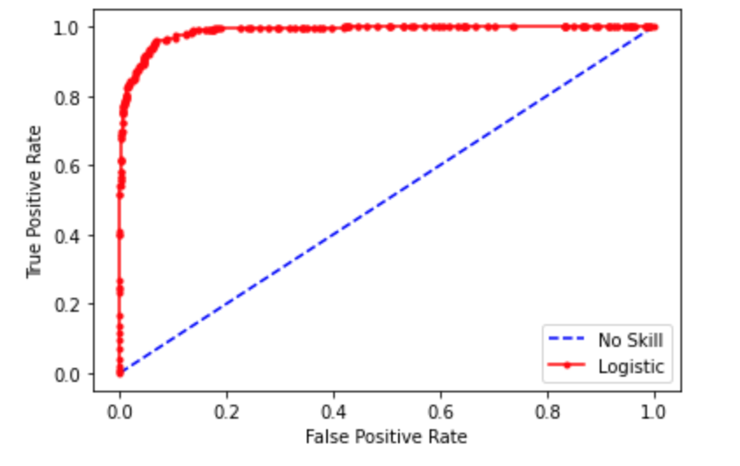

**Fig 25: ROC curve for Logistic Regression on Oversampled data**

(Brownlee, How to Use ROC Curves and Precision-Recall Curves for Classification in Pytho, 2018)

**Neural Network Model Architecture:**

W generated a plot to see the architecture of the CNN model. The diagram shows the parameters used and the number of layers used.

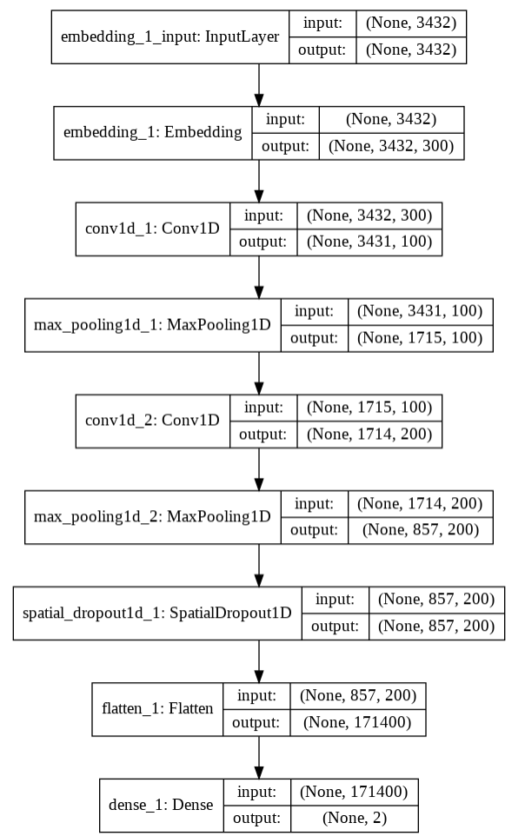

**Fig 26: CNN model Architecture**

(Brownlee, How to Visualize a Deep Learning Neural Network Model in Keras, 2017)

**LESSONS LEARNED:**

The lessons learned from this project are:

* We learned how to predict classes using text data. Using Naïve Bayes and Logistic Regression on text data is another lesson learnt. We also learned the importance of n-grams, how they are derived as well as their essence. Use of TF-IDF matrix and its importance is also learned.
* We got to know what are the methods we need to perform when there is imbalance in the data and how to increase the stability of the model using ROC curve.
* Learning how to give priority to minority classes during the calculation of weights.
* Learned when to use oversampling and the analysis we need to do to perform before doing oversampling. We also learnt about data leakage problem and how to avoid it by doing oversampling only on training data.
* Learned which Neural Network model is best for processing text data and how we use it for our data to predict the class of the target variable.
* We also learned how to use word embedding and how each word is derived to a unique 300d vector and what is the process for connecting an embedding layer to the Neural Network model.
* Learned how to perform hyper tuning on the layers and kernel size for the Neural Network Model.

**FUTURE WORK:**

We can focus on the class weight approach so that we can get an optimal accuracy even without performing oversampling on the training data and predict fraudulent data accurately. We should also focus on alteration of weights so that we need not do oversampling. We can also find patterns in n-gram weights when there is imbalance in the data to help the model give more priority to the low bias class. Using more real word data will help the model learn better and give more accurate results for both the classes in the dataset.

**CONCLUSION:**

From this project, we would like to conclude that:

* Not only job requirements and job description are the important features but all the text features such as title, benefits and other numeric data is also important in predicting the fraudulent job postings.
* Logistic Regression performs better than Naïve Bayes even when we consider all features or only two text features (description and requirements).
* Class weighted approach was done to see if giving priority to low bias class and decreasing priority of high bias class will improve lo bias data’s classification.
* We concluded from this analysis that doing so will reduce the weights of high bias data and this will lead to wrong classification of even high bias data.
* To solve this issue oversampling was done by duplicating the low bias class data and the results proved that oversampling improved the classification of low bias class much better than before. The precision has also increased after oversampling.
* The ROC curve tells us that the Logistic Regression model is performing very well after oversampling the data.
* We would also like to conclude that doing word embedding gives better results than doing TF-IDF vectorization as word embedding understands the context and meaning of the word rather than just using word frequency to find relevant words.
* Using word embedding on the CNN model has given a very good accuracy and is the best model we have used for classifying fraudulent job posting.

**REFERENCES:**

Albert, C. (n.d.). *Inside the Shady New World of Fake Resumes, Professional Interviewees, and Other Job-Seeker Scams*. Retrieved from Inc: https://www.inc.com/magazine/202002/cameron-albert-deitch/resume-fraud-job-applicant-lie-fake-recruiting-interview.html

Brownlee, J. (2017, 12 13). *How to Visualize a Deep Learning Neural Network Model in Keras*. Retrieved from Machine Learning Mastery: https://machinelearningmastery.com/visualize-deep-learning-neural-network-model-keras/

Brownlee, J. (2017, 08 11). *What Are Word Embeddings for Text?* Retrieved from Machine Learning Mastery: https://machinelearningmastery.com/what-are-word-embeddings/

Brownlee, J. (2018, 08 31). *How to Use ROC Curves and Precision-Recall Curves for Classification in Pytho*. Retrieved from Machine Learning Mastery: https://machinelearningmastery.com/roc-curves-and-precision-recall-curves-for-classification-in-python/

Dataman. (2018, 08 10). *Using Over-Sampling Techniques for Extremely Imbalanced Data*. Retrieved from Towards Data Science: https://towardsdatascience.com/sampling-techniques-for-extremely-imbalanced-data-part-ii-over-sampling-d61b43bc4879

Dorion, D. (n.d.). *Employment Scams and Fake Job Postings Leave Job Seekers Wary*. Retrieved from Employment Crossing: https://www.employmentcrossing.com/employers/article/900048624/Employment-Scams-and-Fake-Job-Postings-Leave-Job-Seekers-Wary/

Gaudard, O. (n.d.). *Grouped barplot*. Retrieved from The Pyhton Graph Gallery: https://python-graph-gallery.com/11-grouped-barplot/

Madz. (2020). *Text Classification using Keras/NB(97% Accuracy)*. Retrieved from Kaggle: https://www.kaggle.com/madz2000/text-classification-using-keras-nb-97-accuracy

Monsters, D. (2018, 08 15). *Text Preprocessing in Python: Steps, Tools, and Examples*. Retrieved from Medium: https://medium.com/@datamonsters/text-preprocessing-in-python-steps-tools-and-examples-bf025f872908

Peixeiro, M. (2019, 04 03). *Introduction to Convolutional Neural Networks (CNN) with TensorFlow*. Retrieved from Towards Data Science: https://towardsdatascience.com/introduction-to-convolutional-neural-networks-cnn-with-tensorflow-57e2f4837e18

Singh, V. (n.d.). *Fake Job Post Prediction: Countvec, GloVe, Bert*. Retrieved from Kaggle: https://www.kaggle.com/vikassingh1996/fake-job-post-prediction-countvec-glove-bert

Stanford University. (n.d.). *GloVe: Global Vectors for Word Representation*. Retrieved from Stanford: https://nlp.stanford.edu/projects/glove/

Stecanella, B. (2019, 05 10). *What is TF-IDF?* Retrieved from Monkey Learn : https://monkeylearn.com/blog/what-is-tf-idf/

University of the Aegean. (2014). *EMSCAD logoEmployment Scam Aegean Dataset*. Retrieved from University of the Aegean Laboratory of Information & Communication Systems Security: http://emscad.samos.aegean.gr/